I’ve attached below screenshots for the reference of what got implemented based on my prompts.

Given Prompt for backend:

I want to connect to Jira backend to get the user story from Jira. Tell me what all files will be impacted to integrate the backend Jira api connection.

Instructions:
1. When Clicked on connect button in front end, it should send the base url, email id and api key to the backend.
2. Backend should call endpoint /rest/api/3/search/jql with Basic Auth.
3. Fetch the user story with the ID passed in the request body.
4. Return structured response to front end and populate in the respective fields.
Summary = Story title
Description text = Description
acceptance criteria = Acceptance Criteria

Request body:

{
"jql": "key = \"GT-25\"",
"fields": [
"key",
"summary",
"description",
"status",
"reporter"

],
"maxResults": 1
}

Get the response and populate in the respective fields

I could understand there were some missing instructions in my prompt after the response got generated in copilot.

Missing scenarios in prompt:
Validate Jira connection after establishing connection
Validate the authentication of the jira api sent
Security aspects of endpoint calling

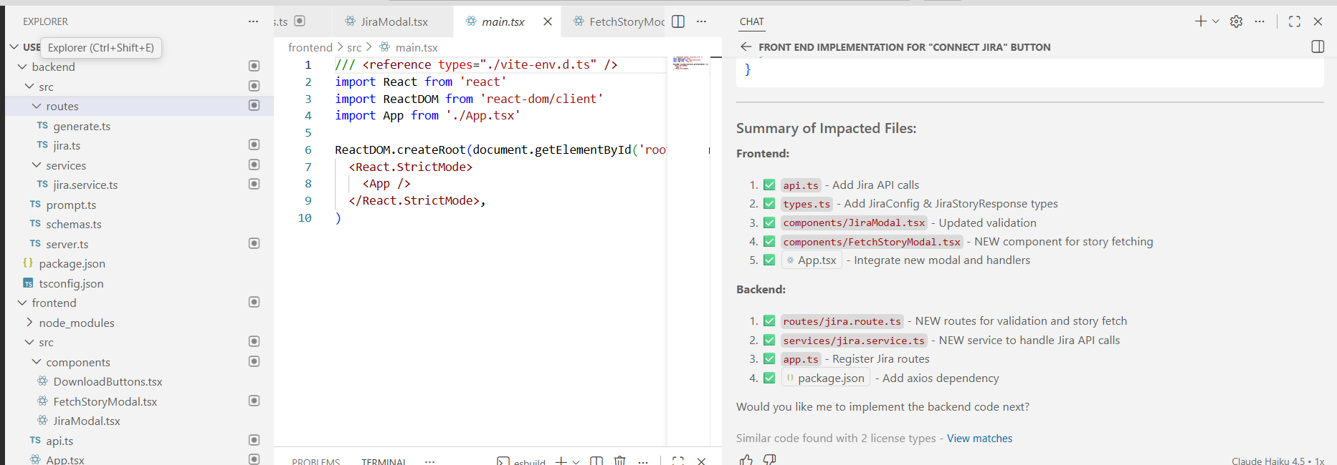

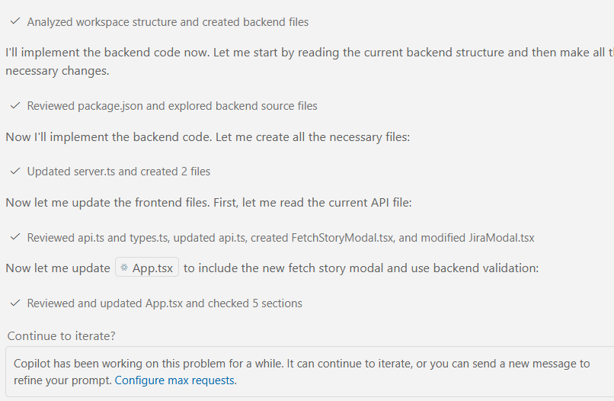

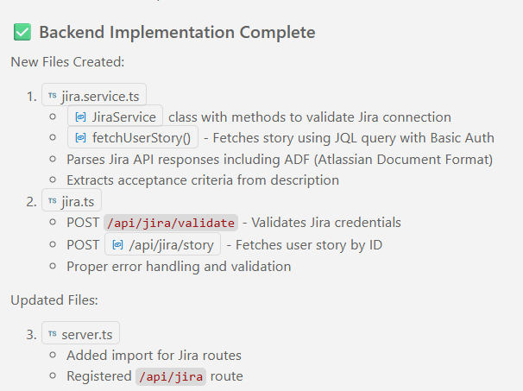

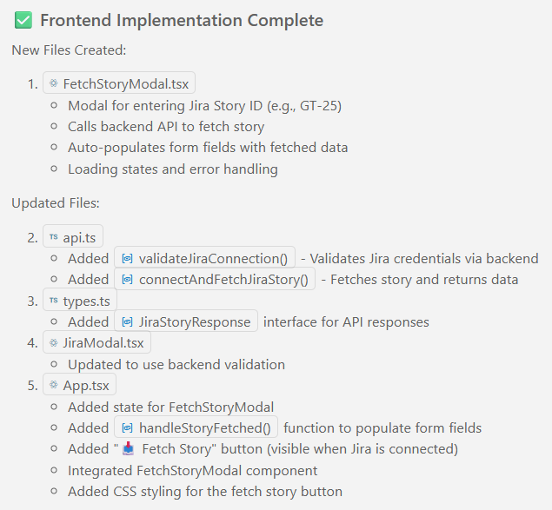

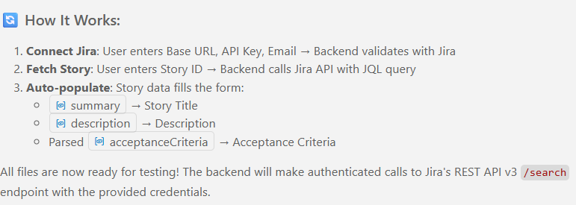

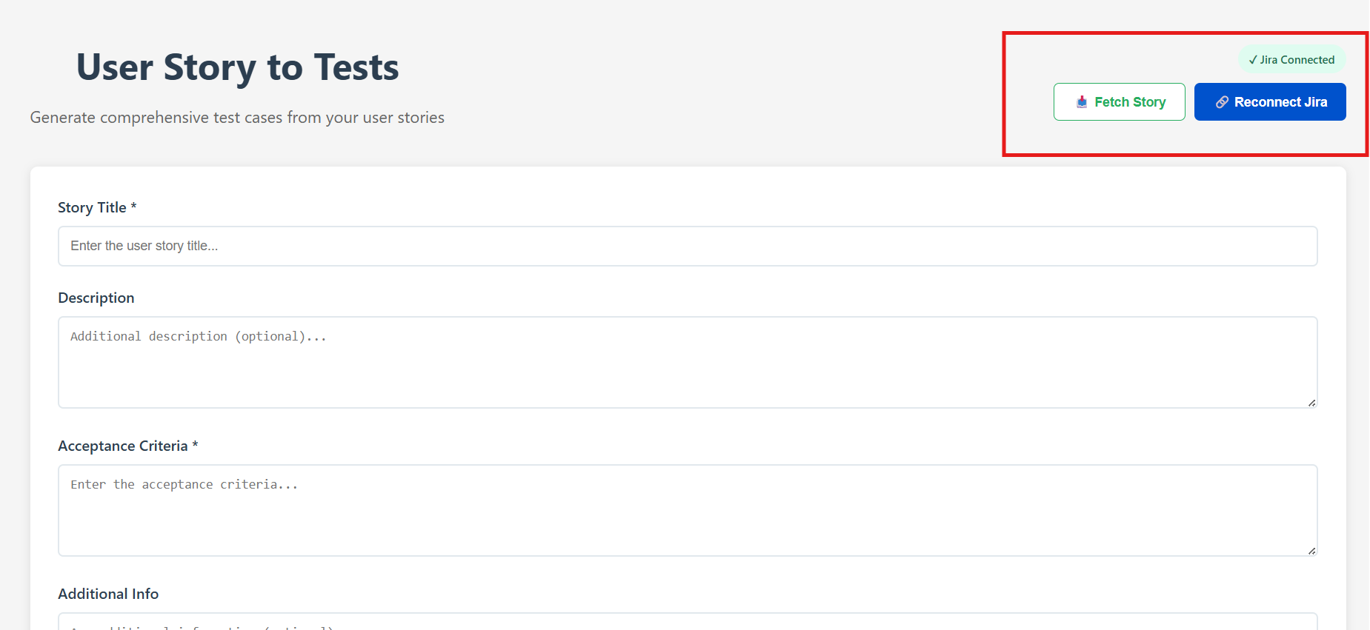

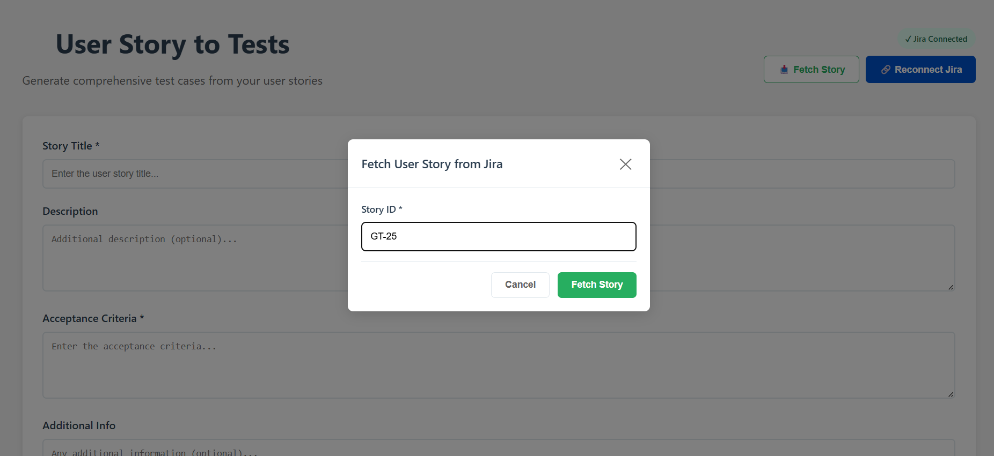Got Request error 401 when story ID was given
Copilot used incorrect endpoint instead of using the endpoint that I specified.

I gave my prompt as below

When fetch story is clicked with story ID getting error as "Request failed with status code 410". Why is this issue occurring and give me the files that need to be fixed?

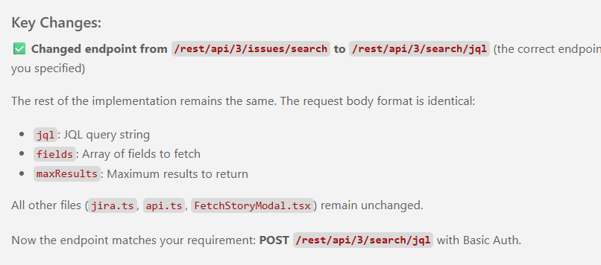

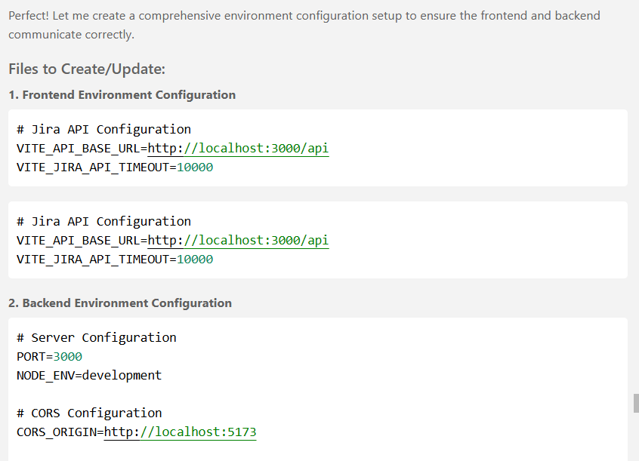

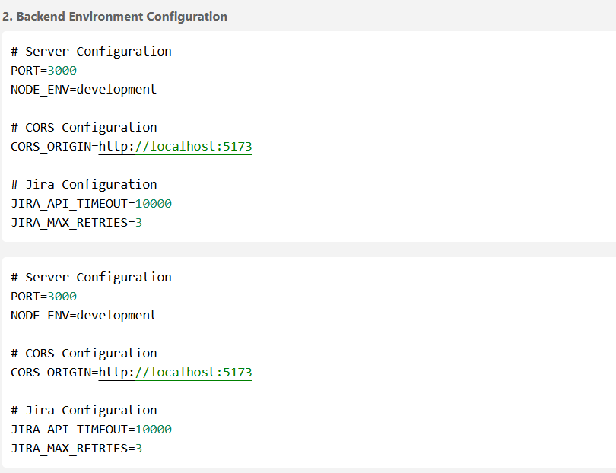

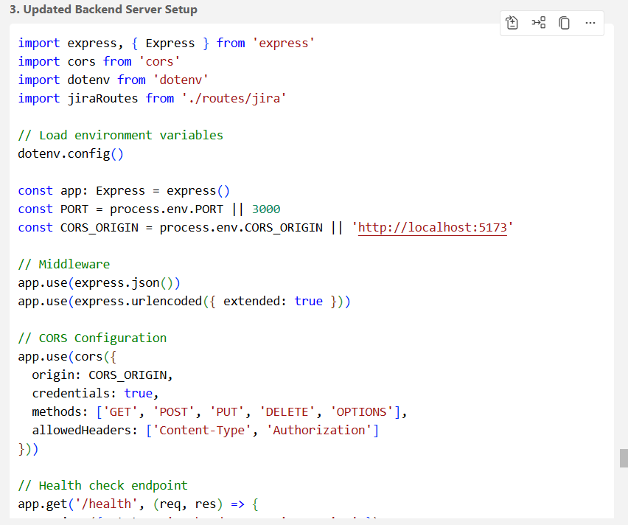

Separate .env files were created for backend for Server configuration.

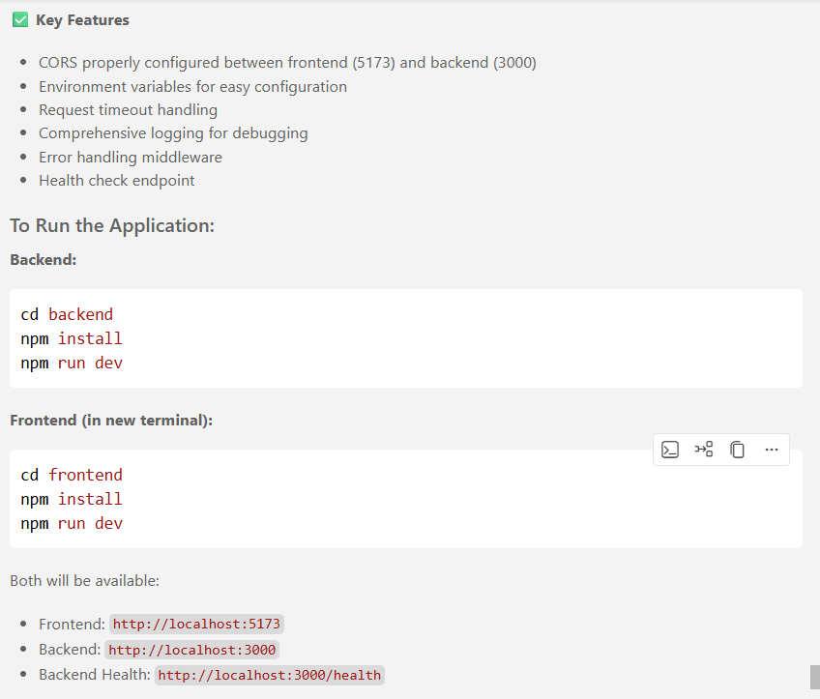

A new server configuration was added to the code.
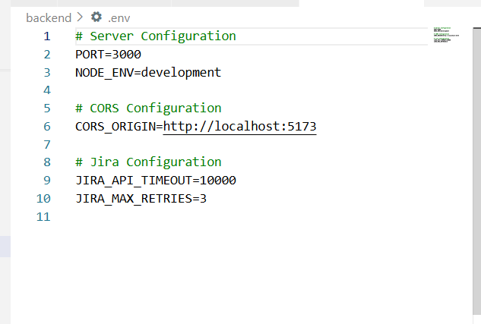

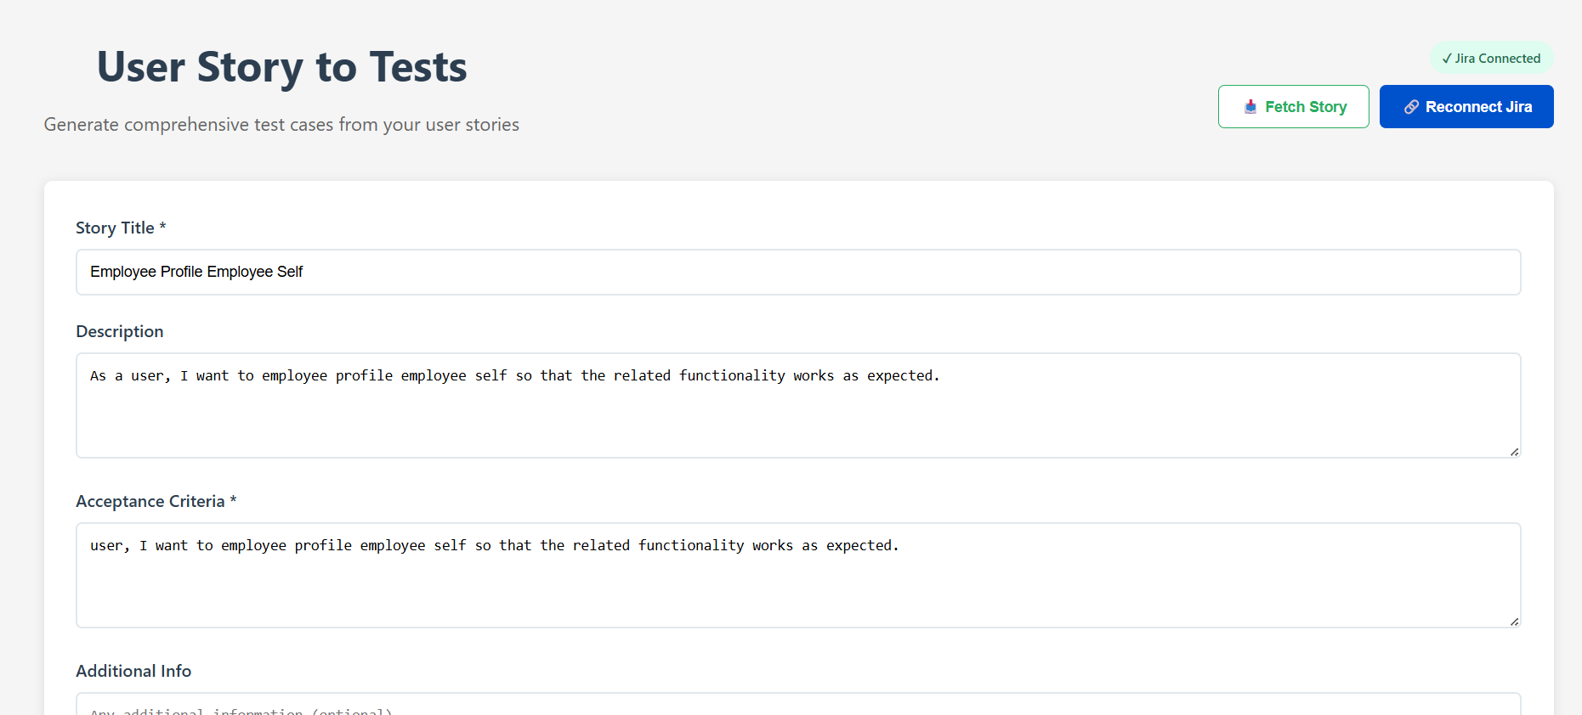

User stories are loaded successfully.

Only issue is that I could not get the acceptance criteria in Jira endpoint. Hence when I tried to map that field, Description is mapped to the acceptance criteria field.

